CODING CONTEST-2 NAME-NIKHITA RS

REG NO-727721EUIT103

CODING

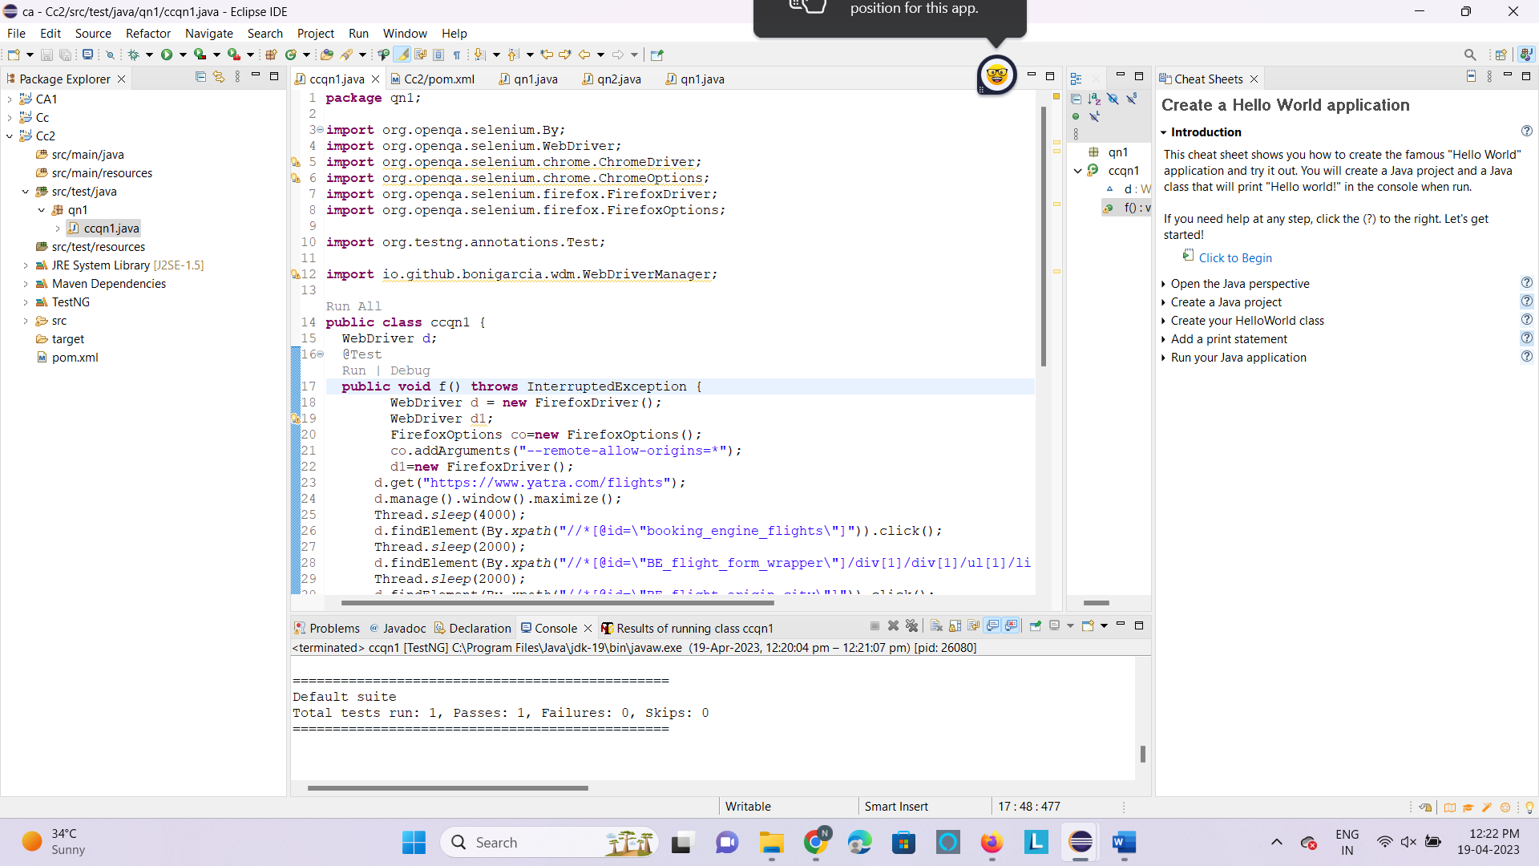

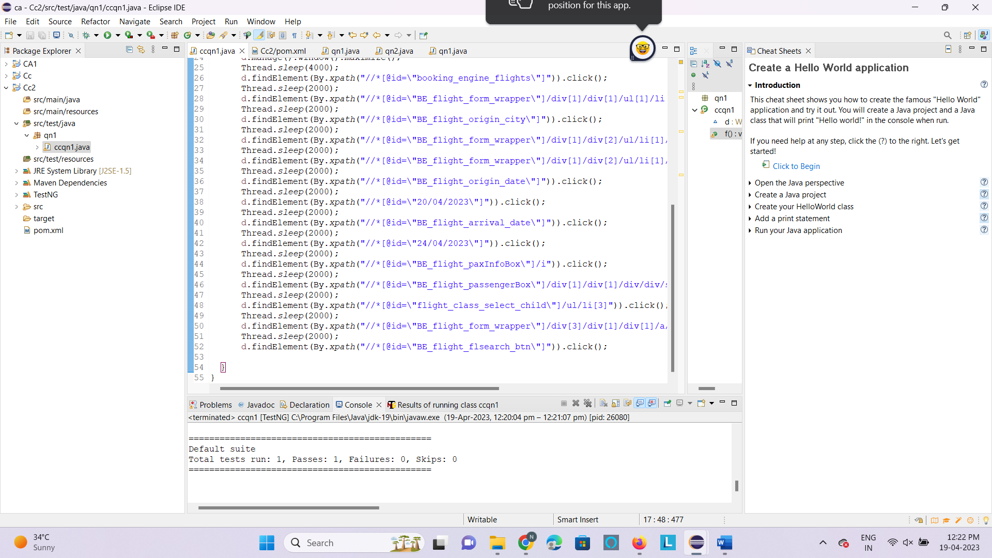

OUTPUT

